AI-Based Hate Speech Detection System for YouTube Videos with a Focus on Religious Contexts



DEPARTMENT OF SOFTWARE ENGINEERING UNIVERSITY OF SARGODHA

SARGODHA – PAKISTAN

SESSION 2021-2025

AI-Based Hate Speech Detection System for YouTube Videos with a Focus on Religious Contexts

***Undertaken By:***

1. STUDENT NAME: Muhammad Ramzan

ROLL NO: BSSE51F21S013

1. STUDENT NAME: Hajra Ashraf

ROLL NO: BSSE51F21S039

1. STUDENT NAME: Muhammad Ali Husnain

ROLL NO: BSSE51F21S037

***Supervised By:***

SUPERVISOR NAME: SIR ABID RAFIQ

SIGNATURE_______________



A DISSERTATION SUBMITTED AS A PARTIAL FULFILLMENT OF THE

REQUIREMENTS FOR THE DEGREE OF BACHELORS IN COMPUTER SCIENCE /

SOFTWARE ENGINEERING

DEPARTMENT OF SOFTWARE ENGINEERING UNIVERSITY OF SARGODHA

SARGODHA – PAKISTAN

SESSION 2021-2025

**FINAL APPROVAL**

The department will provide the final approval page after completing the final evaluation.

# DEDICATION

I sincerely dedicate this project to my beloved parents, whose unwavering support, love, and encouragement have been the foundation of my journey. Their faith in my abilities has been my greatest source of motivation.

I also express my heartfelt gratitude to my teachers, who have shared invaluable knowledge and guidance throughout my academic path. Their mentorship and inspiration have been instrumental in developing my skills and understanding, making this project a reality.

This work is a tribute to my parents and teachers’ profound influence on my life, and I humbly present it as a token of my appreciation for their endless sacrifices and guidance.

# ACKNOWLEDGEMENT

I am deeply thankful to the Almighty for granting me the wisdom, strength and perseverance needed to undertake and complete this project.

I extend my heartfelt gratitude to my parents, whose unwavering support, encouragement, and guidance which have been the foundation of my academic and personal growth. Their sacrifices and faith in my abilities remain a constant source of inspiration.

I wish to express my sincere thanks to my teachers and mentors for their expertise, patience, and invaluable guidance throughout this journey. Their constructive feedback and intellectual insights have enriched this project and depended my understanding of the subject.

Additionally, I am grateful to my peers and colleagues for their encouragement and engaging discussions, which have played a key role in refining my ideas. Lastly, I extend my appreciation to my institution for providing the resources and platform that made this endeavor possible.

# PROJECT BRIEF

|  |  |
| --- | --- |
| PROJECT NAME | AI-Based Hate Speech Detection System for YouTube Videos with a Focus on Religious Contexts |
| ORGANIZATION NAME | UNIVERSITY OF SARGODHA |
| OBJECTIVE  UNDERTAKEN BY | TO BUILD AN AI SYSTEM FOR DETECTING RELIGIOUS HATE SPEECH IN YOUTUBE VIDEOS USING TEXT AND TRANSCRIPT ANALYSIS.  MUHAMMAD RAMZAN  HAJRA ASHRAF  MUHAMMAD ALI HUSNAIN |

SUPERVISED BY SIR ABID RAFIQ

ASSITANT PROFESSOR

UNIVERSITY OF SARGODHA

Python,PyTorch,YouTubeData,Transformers API,NLTKL,Emoji,Firebase,Flask,

|  |  |
| --- | --- |
| STARTED ON | 02-09-2024 |
| COMPLETED ON | 31-05-2025 |
| OPERATING SYSTEM | WINDOWS |

TOOLS USED

# ABSTRACT

Religious-based hate speech has become growing concern on social media platforms like YouTube, threating social harmony and digital safety. To address this issue effective detection mechanisms are crucial to limiting the spread of such harmful content and foster a respectful online environment. Various approaches have been developed to identify and classify hate speech, primarily focusing on analyzing textual data to differentiate between hate and non-hate content. This research provides a comprehensive review of the existing for hate speech detection techniques, with a focus on YouTube comments. In this study, we propose a system that classifies comments into hate and non-hate categories, by utilizing advanced natural language processing techniques and deep learning models. First, we classify the existing approaches into three categories: keyword-based methods, deep learning-based methods, and hybrid approaches. Second, widely used supervised learning techniques for hate speech detection are reviewed in the context of their application to YouTube content. Third, a comparative analysis of the strengths, effectiveness and limitation of these methods is presented. The system architecture is also in detailed, including data preprocessing for cleaning and normalization, feature extraction to identify linguistic and contextual patterns, and classification using deep learning models for accurate detection. This research highlights the challenges and opportunities in addressing religious hate speech, providing valuable insights and gaudiness for future advancement in combating such harmful content effectively.

## **TABLE OF CONTENS**

1 INTRODUCTION .....................................................................................................1

1. REQUIREMENT SPECIFICATIONS .....................................................................3
   1. Product Scope ........................................................................................................3
   2. Product Description ...............................................................................................3
      1. Product Perspective ............................................................................................3
      2. Product Functionality .........................................................................................3
      3. Operating Environment ......................................................................................4
   3. Specific Requirements ...........................................................................................4
      1. Functional Requirements ...................................................................................4
      2. Behavioral Requirements ……………………………………………………...4

2.3.3 External Interface Requirements ........................................................................5

* 1. Non-functional Requirements.................................................................................5

2.4.1 Performance Requirements ...................................................................................5

* + 1. Safety and Security Requirements .....................................................................5
    2. Software Quality Attributes …………………………………………………...5
  1. Data Requirements .................................................................................................5
  2. Compliance and Regulatory Requirements ............................................................6
  3. Scalability and Future Expansion ...........................................................................6
  4. Usability and Accessibility Considerations ............................................................6
  5. Requirement Validation and Verification................................................................6

3 INPUT AND OUTPUT DESIGNS ……………………………………………........7

* 1. Use Case Diagram ...................................................................................................7
  2. Sequence Diagrams .................................................................................................8

3.2.1 User Registration ……………………………………………………………...8

3.2.2 User Login ………………………………………………………………….....9

3.2.3 Input Validation …………………………………………………………….....9

3.2.4 Fetching Comments ………………………………………………………….10

3.2.5 Text Preprocessing …………………………………………………………..11

3.2.6 Feature Extraction …………………………………………………………...12

3.2.7 Text Classification …………………………………………………………...13

3.2.8 System Sequence …………………………………………………………….13

3.3 Activity Diagram ………………………………………………………………..14

3.4 Class Diagram …………………………………………………………………...15

3.5 Workflow Diagram …………………………………………………………….. 16

4 DESIGN SPECIFICATIONS .....................................................................................17

* 1. Introduction ..........................................................................................................17
  2. Composite Viewpoint ...........................................................................................17
  3. Logical Viewpoint ................................................................................................17
  4. Information Viewpoint .........................................................................................18
  5. Interaction Viewpoint ...........................................................................................18
  6. State Dynamics Viewpoint ...................................................................................18
  7. Algorithmic Viewpoint ………………………………………………………….18
  8. Architectural Viewpoint ........................................................................................19
  9. Security Design......................................................................................................19
  10. Scalability and Performance Viewpoint ………………………………………...19
  11. Integration and Deployment Strategy ...................................................................19
  12. User-Centered Design ...........................................................................................20
  13. Advanced Modeling Techniques ..........................................................................20
  14. Environmental Impact Analysis ............................................................................20
  15. Compliance with Standards ..................................................................................20

5 DEVELOPMENT AND TOOLS............................................................................... 21

* 1. Introduction ...........................................................................................................21
  2. Development Plan..................................................................................................21
  3. Development Tools................................................................................................21
  4. Conclusion and Future Work/Extensions .............................................................22
  5. Software Engineering Practices ............................................................................22
  6. Version Control and Collaboration Tools .............................................................22
  7. Integration and Deployment Tools .......................................................................22
  8. Quality Assurance Tools .......................................................................................22
  9. Security Measures and Tools ................................................................................23
  10. Comparative Analysis of Tools ........................................................................... 23
  11. Challenges and Mitigation Strategies …………………………………………...24

1. QUALITY ASSURANCE ........................................................................................25
   1. Introduction ...........................................................................................................25
   2. Traceability Matrix ...............................................................................................25
   3. Test Plan ................................................................................................................25
   4. Testing Strategies and Methodologies ..................................................................28
   5. Test Case Design ...................................................................................................29
   6. Automated Testing ................................................................................................29
   7. Performance Testing .............................................................................................29
   8. Security Testing ....................................................................................................29
   9. Usability Testing....................................................................................................30
   10. Defect Tracking and Management ....................................................................... 30
   11. QA Tools and Technologies .................................................................................30

7  USER MANUAL .......................................................................................................31

* 1. Introduction ...........................................................................................................31
  2. Operating Manual .................................................................................................31
  3. Security Measures ……………….........................................................................34
  4. FAQs and Support Information ............................................................................34

8 SYSTEM DESIGN AND CODING SCREENS........................................................ 35

* 1. User Interface Design……...............................................................................35
  2. Login Screen .........................................................................................................36
  3. Registration Screen ...............................................................................................37
  4. Dashboard Screen .................................................................................................38
  5. Analysis Youtube Comments............................................................................... 39
  6. Analysis Result..…………………………………………………………………40

* 1. View Report …......................................................................................................41
  2. WorkingProcess………………............................................................................41
  3. Text Analysis for Hate Speech Detection ……………………………………….44
  4. Social Media Monitoring ………………………………………………………..45
  5. Custom Solution …………………………………………………………………46
  6. Our Services ……………………………………………………………………..47
  7. Log Out ………………………………………………………………………….48
  8. Footer …………………………………………………………………………...49

9  **Conclusion** ................................................................................................................42 9.1 Summary ...................................................................................................................42

**LIST OF FIGURES**

Figure 1.1: Increasing trend ......................................... **Error! Bookmark not defined.**

## **LIST OF TABLES**

|  |  |
| --- | --- |
| List of Tables | Page no |
| Table 1 SYSTEM REQUIREMENTS ANALYSIS |  |
| Table 2 System Functional Requirements |  |
| Table 3 Non-Functional Requirements (e.g., performance, security) |  |
| Table 4 User Requirements and Expectations |  |
| Table 5 LITERATURE REVIEW |  |
| Table 6 Summary of Related Works/Studies |  |
| Table 7 Comparative Analysis of Algorithms/Methods |  |
| Table 8 Research Gaps Identified |  |
| Table 9 SYSTEM DESIGN AND ARCHITECTURE |  |
| Table 10 System Design Specifications (e.g data flow, module interaction) |  |
| Table 11 Component Breakdown and Responsibilities |  |
| Table 12 Database Schema Design |  |
| Table 13 METHODOLOGY |  |
| Table 14 Methodology Overview |  |
| Table 15Data Collection Methods |  |
| Table 16 Algorithm/Model Selection Criteria |  |
| Table 17 RISK MANAGEMENT PLAN |  |
| Table 18 Risk Identification Matrix |  |
| Table 19 Risk Mitigation Strategies |  |
| Table 20 Impact and Likelihood Assessment |  |
| Table 21 TESTING STRATEGY AND PLAN |  |
| Table 22 Testing Phases/Stages |  |
| Table 23 Test Cases and Expected Outcomes |  |
| Table 24 Test Results and Analysis |  |
| Table 25 PROJECT TIMELINE AND MILESTONES |  |
| Table 26 Detailed Milestone Breakdown |  |
| Table 27 Key Deliverables and Deadlines |  |
| Table 28 Dependency Mapping |  |
| Table 29 BUDGET AND COST ANALYSIS |  |
| Table 30 Budget Breakdown (hardware, software, resources) |  |
| Table 31 Estimated vs Actual Costs |  |
| Table 32 Cost-Benefit Analysis |  |
| Table 33 FUTURE WORK AND IMPROVEMENTS |  |
| Table 34 Future Enhancements/Upgrades |  |
| Table 35 Challenges and Proposed Solutions |  |
| Table 36 CONCLUSION AND SUMMARY |  |
| Table 37 Project Achievements and Results |  |
| Table 38 Lessons Learned |  |
| Table 39 Recommendations for Future Projects |  |

1 INTRODUCTION

### **System Introduction**

The Religious Discrimination Detection System is deployed to identify instance of religious discrimination in user-generated content on YouTube. Its primary objective to analyze comments on YouTube videos using advanced deep learning techniques and best practices to identify and classify hate speech effectively. The system play’s a crucial role in today’s technological and social landscape, addressing the increase concerns surrounding the spread and targeting of hate speech online. It aims to contribute to creating a safer and more inclusive digital environment.

**1.2** **Background of the System**

Traditional methods such as manual review and basic content filtering, but prove inadequate due to the vast amount of online content. Recent advancement in machine learning and deep learning have improved detection accuracy, but existing systems still struggles with challenges such as multilingual content and varying contextual nuances. Our aim is to overcome these limitation by integrating state-level language processing techniques with robust distribution models.

**1.3** **Objectives of the System**

The primary objective of our system is to improve accuracy and efficiency by using multilingual datasets and integrating multi models to ensure precise identification of hate speech.

**1.4** **Significance of the System**

Socialmedia platforms particularly YouTube are widely used today, often serving as medium for both individual and extremist groups to spread hate. The significance of the system lies in its potential to create a positive impact on the online industry, community and society. By providing automated tool for detecting religious hate speech on YouTube, the system reduce the spread of harmful content and encourages respectful online interactions. Furthermore, it offers a scalable solution to real-world-problems with potential for integrated across various platforms.

**1.6** **Challenges in Existing Solutions**

Hate speech detection systems encounter several challenges including difficulty in handling ambiguity and understanding context. Additionally, issues related data quality and availability such as limited datasets and noisy or biased data, further complicated process. Our proposed system addresses these challenges by employing sentiment analysis and word embedding by using pre-trained models for better contextual understanding, and supporting multilingual data processing.

**1.7** **Key Features of the Proposed System**

**Automated Comment Fetching:** Comments are retrieved by using YouTube API.

**Advanced Preprocessing:** The system preprocesses the text by using stop word removal, tokenization, and normalization techniques for cleaning.

**Feature Extraction:** The techniques used for feature extraction techniques like BERT.

**Robust Classification Models:** For accurate classification implement Xml Roberta.

**User-Friendly Interface:** The UI of our system is simple and easy to use for users to input data and view results.

**1.8 Expected Outcomes**

Our system aims to increase performance in detecting hate with great efficiency and is more scalable. User satisfaction will increase by high usability and clear results for users.

**1.9** **Research Contribution**

Developing a comprehensive system for hate speech detection using YouTube comments. To improve detection system accuracy, precision, and efficiency, we utilized advance NLP and deep-learning techniques. Providing a scalable solution that can be flexible to various platforms and languages.

1. REQUIREMENT SPECIFICATIONS

2.1 Product Scope

The Religious Hate Speech Detection System is built to automate the detection of religious hate speech in user-generated content on YouTube. The system will analyze the comments of a particular YouTube video and label them as hate speech or non-hate speech using sophisticated Natural Language Processing and deep learning methods. The system process’s drawbacks are only textual data handling, dependence on the quality of training datasets, and requiring internet connectivity for fetching comments via the YouTube API. The specific needs it addresses are improving online safety, reducing the spread of harmful content, and promoting inclusivity in online interactions

2.2 Product Description

The Religious Hate Speech Detection System aims to create a safer online environment by enhancing the interactivity of users within YouTube comments. Its primary goal is to provide an automated, scalable tool for content analysis. The system is designed to serve social media platforms, researchers, content moderators, and policymakers. The main functionalities of our system include user registration and login, input of video URL/text, fetching comments extracted from YouTube, comments preprocessing, feature extraction, and classification of comments.

2.2.1 Product Perspective

The system can help in the larger ecosystem of online content moderation and user safety. It connects with other systems like YouTube's own moderation tools and external hate speech detection tools. Components like the YouTube API for fetching comments and pre-trained models like Xlm-Roberta for classification. Integrations are about interfacing these APIs and models for the desired action to be performed.

2.2.2 Product Functionality

User Registration and Login:

Allow user to register and login accounts securely.

Input Video URL/Text:

Allow users to input a video URL analysis. Get Comments from YouTube videos using API.

Preprocessing of Fetched Comments:

Removing Stop words, tokenizing and removing emoji’s/URLs.

Feature Extraction of Comments:

Different techniques like Tokenization and word embedding is used for feature extraction.

Classification of Comments: By using deep learning models to Classify comments as hate or non-hate.

2.2.3 Operating Environment

The system will functional within the specified technical framework

Hardware: Standard servers or cloud infrastructure design to manage large dataset.

Software: Flask framework, Python for deep learning models, and libraries like PyTorch.

Network: Stable internet access required for retrieving comments from the YouTube.

Support modern web browsers and scalable cloud infrastructure.

2.3 Specific Requirements

* + 1. Functional Requirements

User Registration and Login: Allow user to register and login account securely.

Input Video URL/Text: Allow users to input URLs for analysis.

Fetch Video Comments using API: The system integrate with You Tube API

retrieve comments.

Preprocessing of Comments: Retrieved comments are effectively clean and preprocess.

Feature Extraction: Advanced NLP techniques will employed to extract meaningful features from preprocessed comments.

Classification of Comments: System precisely classify comments into hate or non-hate classes.

* + 1. Behavioral Requirements

User Inputs: The system design to handle and validate variety of user inputs effectively make sure robustness in contrast to invalid data.

Error Scenarios: System must gracefully handle errors, such as failed API calls or Unexpected data formats.

Environmental Changes: It should be adaptable to changes in the YouTube API or underlying models to minimize downtime.

* + 1. External Interface Requirements

This system utilizes RESTful APIs with JSON data exchange communication. It integrate with the YouTube API retrieve comment. A User friendly Web-based Interface that allows users to input data and analysis results.

* 1. Non-functional Requirements

2.4.1 Performance Requirements

The System is designed for high performance offering rapid analysis results within a few seconds. It can efficiently handle a large volume of data and many users at the same time process thousands of comments every minute.

2.4.2 Safety and Security Requirements

The system prioritize data protection and user privacy. It Ensure encryption of both user data transmit and when stored. The system Comply privacy regulations and restrict access to authorized user only. To enhance security OAuth 2.0 Implement for secure API access and prevent unauthorized access.

2.4.3 Software Quality Attributes

The system emphasized maintainability the Code should be modular and well-documented for easy maintenance and updating. The System should strive high uptime and incorporate robust error recovery mechanisms. The User Interface should be designed intuitive and accessible to users of all skill levels. The system should be readily deployable on various cloud platforms and compatible with different operating systems.

2.5 Data Requirements

The system will handle the following data:

Inputs: YouTube video URLs.

Outputs: Classification results categorized as (hate or non-hate).

Storage: User information and result analysis will securely store in database.

Data Flow: Data will traverse through system start from user input to through

API calls than preprocessing data, feature extraction, and classification models.

2.6 Compliance and Regulatory Requirements

It Ensure compliance with general data protection data for safeguard user privacy. The system development Adhere to relevant ISO standards. The system will design to be Accessible to all users by Follow WCAG standards.

2.7 Scalability and Future Expansion

The system leverage a distributed architecture Implementing enable horizontal scalability. Cloud infrastructure will be Utilized for scalable storage and processing. Allowing for the easy addition of new features and model updates.

2.8 Usability and Accessibility Considerations

Provide simplified and initiative user interface for all user types.

Accessibility: Assurance compatibility with screen readers and support keyboard for navigation.

Compliance: Ensure Adhere to WCAG accessibility standards.

2.10 Requirement Validation and Verification

Validation Methods: Utilize stakeholder reviews, user testing, and acceptance testing to confirm requirements align with expectations.

Verification Methods: Carry out unit testing, integration testing, and system testing to ensure all requirements are fulfilled.

3 INPUT AND OUTPUT DESIGNS

3.1 Use Case Diagram

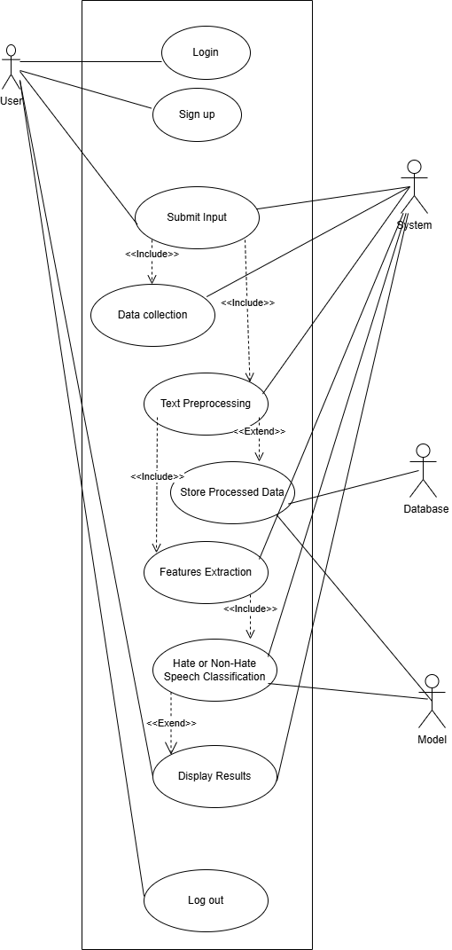

3.2 Sequence Diagrams

3.2.1 User Registration

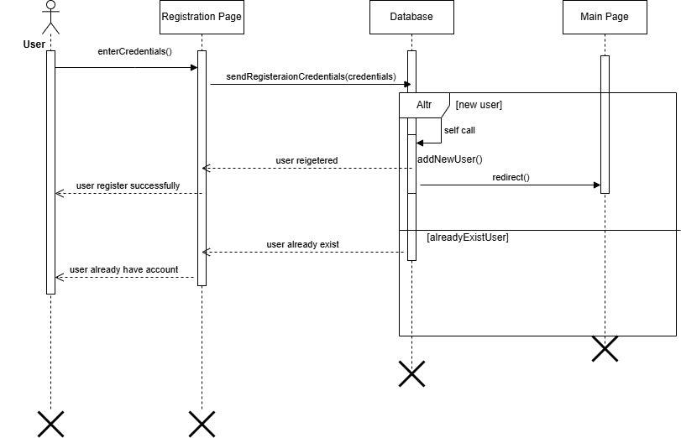

3.2.2 Login Diagram

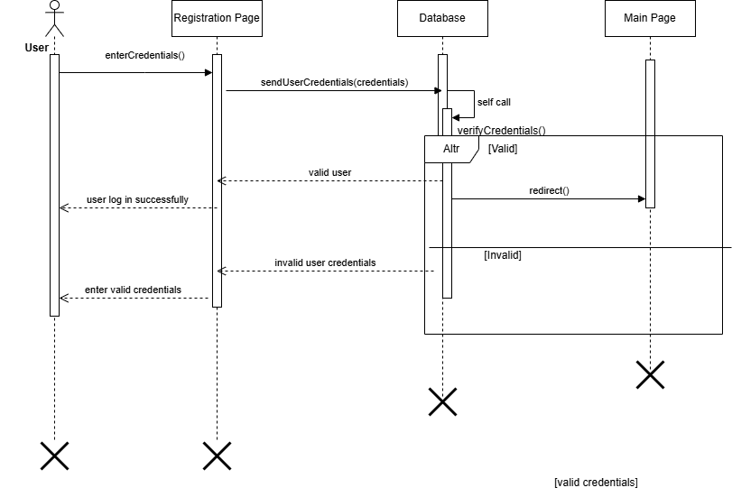

3.2.3 Input Validation Diagram

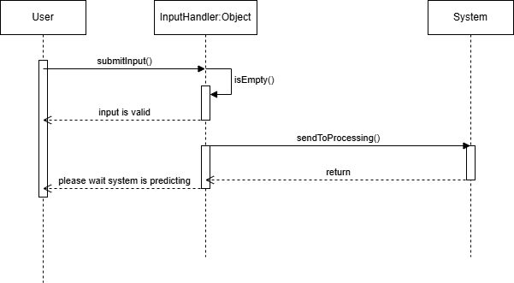

3.2.4 Fetching Comments Diagram

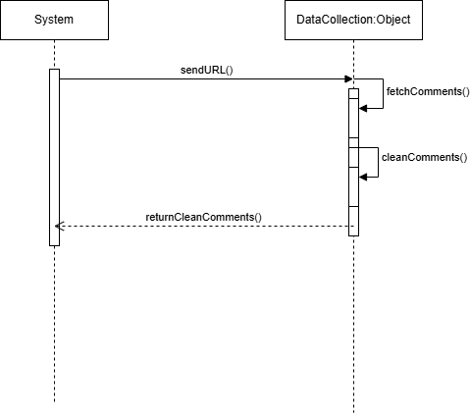

3.2.5 Text Preprocessing Diagram

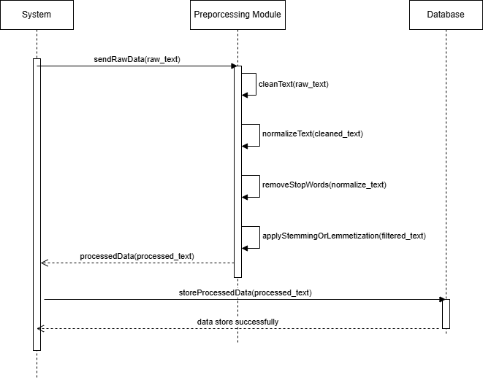

3.2.6 Contextual Feature Extraction Diagram

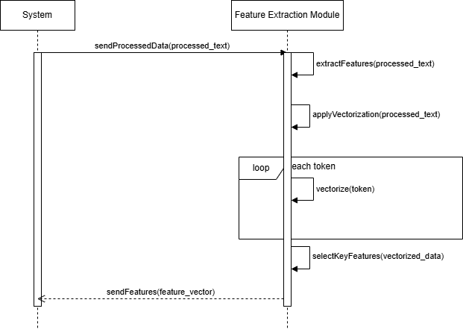

3.2.7 Classification Diagram

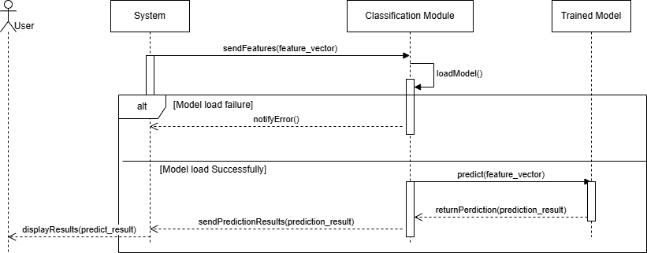

3.2.8 System Sequence Diagram

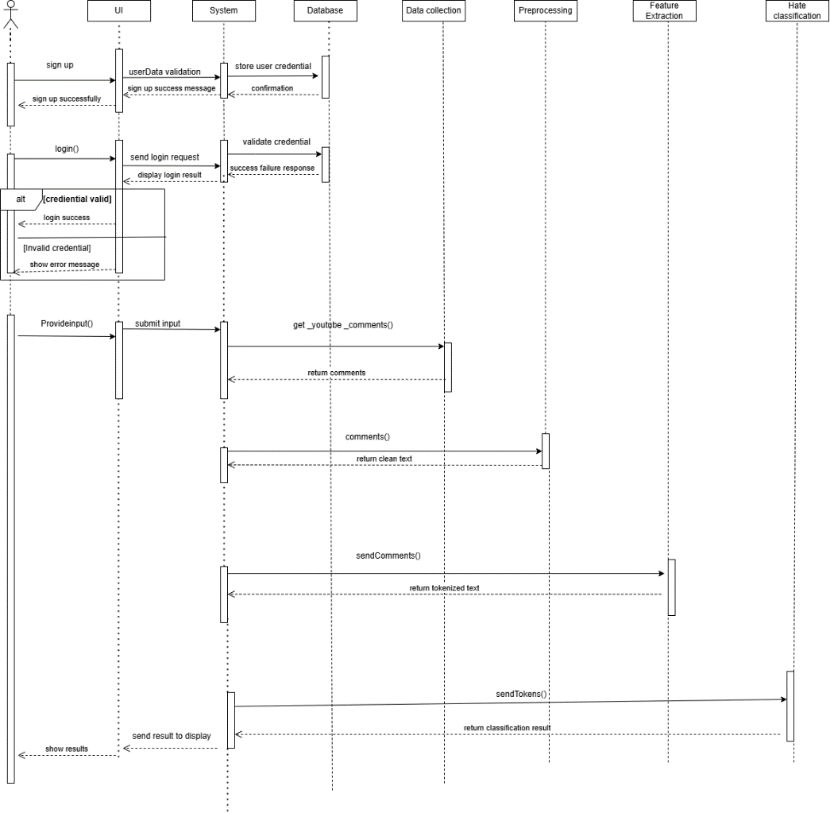

3.3  Activity Diagram

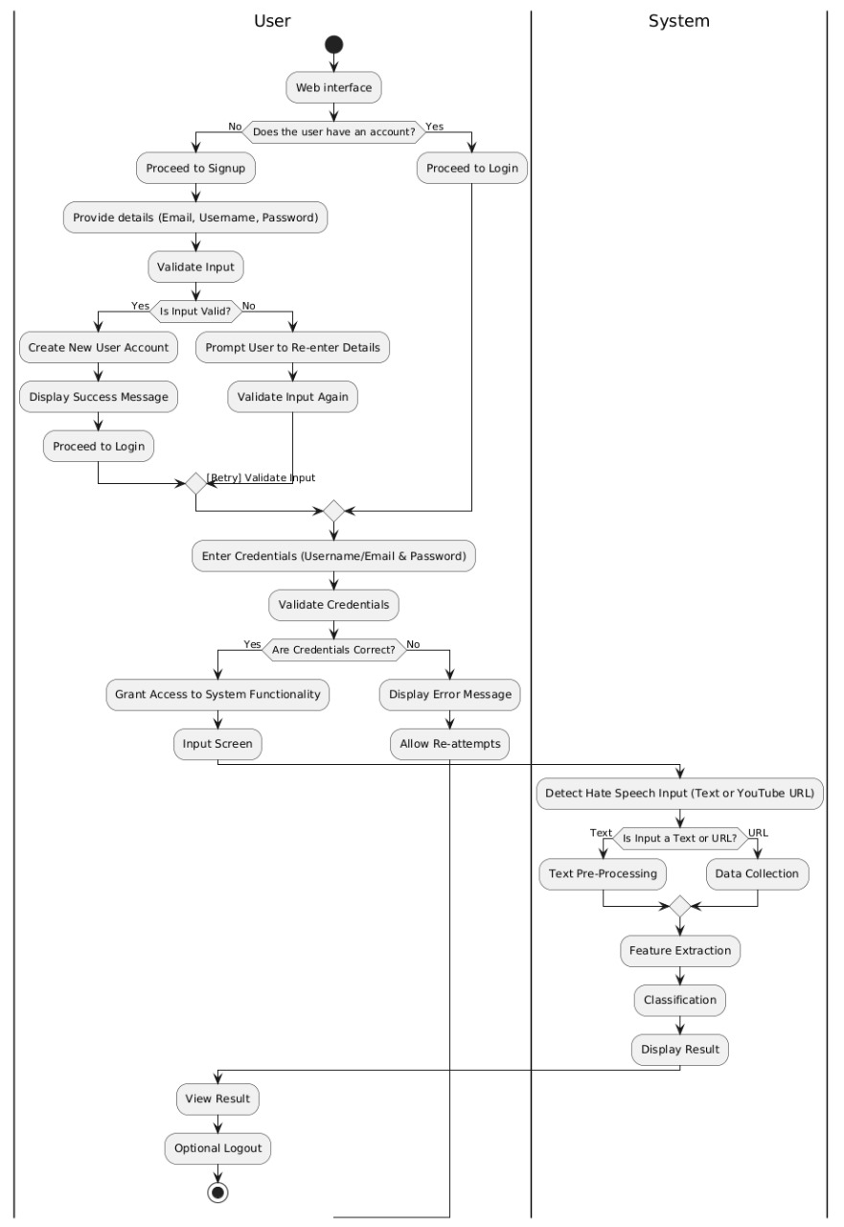

3.4  Class Diagram

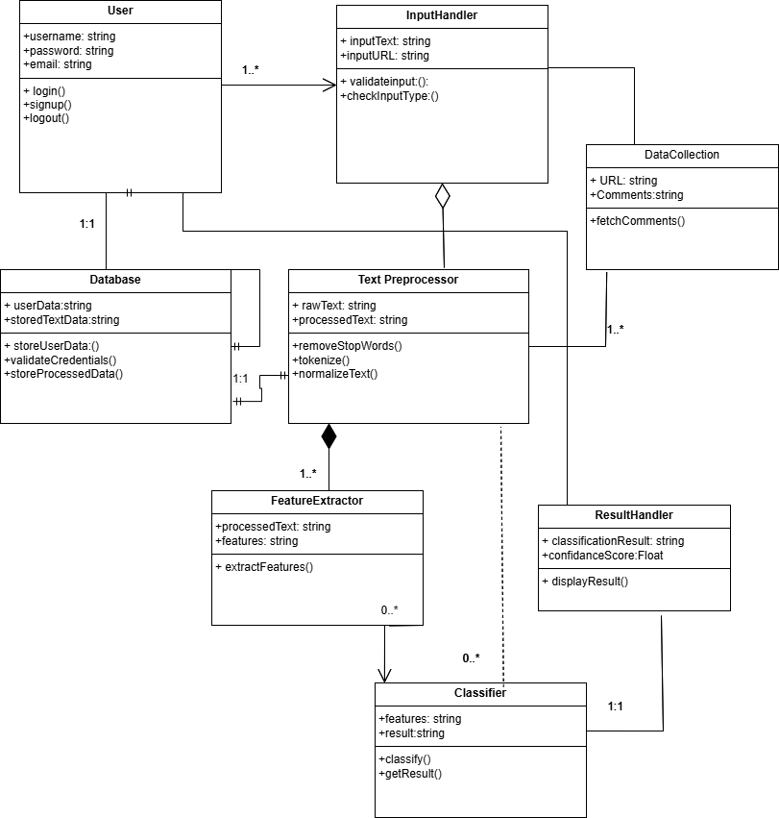

3.5  Workflow Diagram

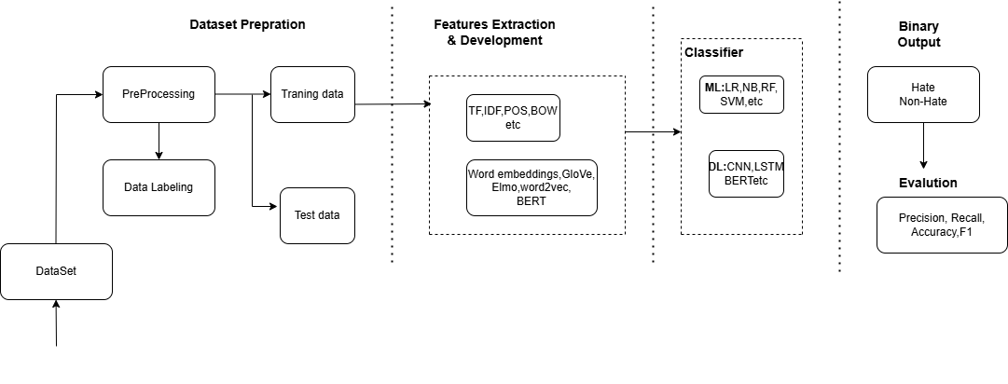

4  DESIGN SPECIFICATIONS

4.1 Introduction

The design approach for the Religious Hate Speech Detection System adopts a structured and modular methodology to ensure scalability, maintainability, and efficiency. A structured design is crucial for clearly defining the system’s components, interactions, and dependencies. Modular design facilitates simplified development, testing, and future upgrade. The methodologies incorporate Agile practice for iterative development and continuous feedback, along tools like UML for diagramming and Python with leveraging library PyTorch for implementing deep learning models.

4.2 Composite Viewpoint

The system consist several key points:

User Interface: Facilitates user interaction, such as logging, submitting video

URLs, and viewing results.

API Integration Module: Retrieve comments from YouTube.

Preprocessing Module: Clean and preprocess data for analysis.

Classification Module: Use deep learning models to categorize comments as

hate or non-hate.

Database: Store user data, comments, and classification results.

4.3 Logical Viewpoint

The system’s logical structure emphasizes data flow and process organization.

Class Diagrams: Illustrate the objects and their relationships.

Entity-Relationship Diagrams (ERDs): Visualize the relationships between data

Entities in the system.

Data Flow Diagrams (DFDs): Map the movement of data between entities in the

system.

4.4 Information Viewpoint

Data storage and management strategies utilize a relational database to ensure efficient and structured data organization. Key elements include:

Database Schemas: Defining tables, fields, and their relationships.

Data Flow Diagrams: Visualize the movement of data within the system.

Data Dictionaries: Specify data elements, their types, and constraints.

Data is structured to enable secure and efficient access, with user

Data that is encrypted at both rest and in transit.

4.5 Interaction Viewpoint

The system components interact with each other and with external systems through clearly defined interfaces:

Sequence Diagrams: The sequence of operations for various system processes.

Collaboration Diagrams: Illustrate how components collaborate to achieve functionality.

4.6 State Dynamics Viewpoint

The system’s behavior over time is represented using state transition diagrams. These diagrams show:

Key States: Including logged in, data fetching, processing, and displaying results.

Transitions: Started by events such as user inputs or completion of data retrieval.

4.7 Algorithmic Viewpoint

The system employs various key algorithms for text processing and classification:

Preprocessing Algorithms: Used for cleaning and tokenizing text.

Contextual learning.

Classification Algorithms: Xlm-Roerta models.

Pseudo code and flowcharts can be utilized to outline and detail these algorithms clearly.

4.8 Architectural Viewpoint

The system architecture consists of both hardware and software components:

Hardware: Servers or cloud infrastructure to host the application and manage databases.

Software: Flask framework for the Backend, deep learning libraries for implementing models, and APIs for system integration. Deployment diagrams illustrate the physical arrangement of components and their communication channels.

4.9 Security Design

The system employs security mechanisms to ensure data integrity, confidentiality, and availability:

Encryption: Data is secured during transit using HTTPS and at AES encryption rest using.

Authentication: OAuth 2.0 is utilized to provide secure API access.

Access Control: Role-based access control is implemented to restrict

functionalities based on user roles.

4.10 Scalability and Performance Viewpoint

The system effectively manages workloads while maintaining performance through the following strategies:

Load Balancing: Requests are distributed across multiple servers to ensure an even workload.

Caching: In-memory data storage to reduce database load.

Database Optimization: Indexing and query optimization techniques are implemented to improve response times.

4.11 Integration and Deployment Strategy

The system integrates with external platforms, such as YouTube API to retrieve comment. The deployment strategy includes:

CI/CD Pipelines: To enable automated testing, integration, and deployment processes.

Containerization: Utilizing Docker to ensure consistent deployment environments.

4.12 User-Centered Design

The system incorporates several design elements enhance user experience:

Usability Testing: Conducting regular user testing to gather feedback and refine the interface.

Interface Design Principles: Ensuring clear navigation, intuitive inputs, and responsive design.

Accessibility Considerations: Adhering to WCAG standards to make the system accessible to all users.

4.13 Advanced Modeling Techniques

The design phase employs advanced modeling techniques, including :

Deep Learning-Based Predictions: To improve classification accuracy.

Real-Time Simulations: To evaluate system performance under various scenarios.

4.14 Environmental Impact Analysis

The environmental impact of the system includes:

Energy Efficiency: Leveraging energy-efficient servers and optimizing code to reduce power consumption.

Sustainability Measures: Adopting practices to minimize environmental footprint, such as selecting cloud providers with sustainable practices.

4.15 Compliance with Standards

The system complies with applicable design standards, protocols, and best practices:

ISO Standards: For software security and development.

Software Development Frameworks: Including Agile and DevOps practices.

Domain-Specific Guidelines: Ensuring adherence with industry-specific regulations.

5 DEVELOPMENT AND TOOLS

5.1 Introduction

To ensure effective implementation and project success, the development process for the Religious Hate Speech Detection System follows a structured approach. We utilize the Agile development model for iterative development and continuous feedback

5.2  Development Plan

The development plan includes the following steps:

Planning: Defining the project scope, objectives, and requirements.

Design: Creating system architecture, diagrams, and detailed design documents.

Implementation: Implementation involves Developing the system components, integrating APIs, and implementing deep learning models.

Testing: Conducting unit, integration, system, and user acceptance testing.

Deployment: The last step is Deploying the system on a cloud platform, ensuring its accessibility to users.

5.3 Development Tools

The tools used in the project include:

Programming Languages:

We Select Python for deep learning and backend, JavaScript for frontend. Python's vast libraries support deep learning, and for interactive web interfaces JavaScript is ideal.

Frameworks:

Flask for backend. Flask provides a lightweight, simple and flexible web framework, while enabling efficient UI development.

APIs:

YouTube Data API for fetching comments. It provides a reliable and efficient way to retrieve comments from YouTube.

Deep Learning Libraries**:**

PyTorch,Transformers , These libraries provides powerful tools for implementing and training deep learning models.

Databases:

Firebase for data storage. Firebase is scalable, robust and it support complex queries.

5.4 Conclusion and Future Work/Extensions

The system is not developed yet.

5.5 Software Engineering Practices

We use Agile methodology because it ensures efficient project management through iterative development, regular feedback, and continuous improvement. These practices would facilitate effective communication, flexibility, and rapid response to changes.

5.6 Version Control and Collaboration Tools

For Version Control, we recommend Git. Git provides distributed version control, and is easier to manage code changes and collaborate with team members

For the Collaboration tool and repositories hosting GitHub would be used. Because it offers repository hosting, issue tracking, and collaboration features, which foster efficient team collaboration.

5.7 Integration and Deployment Tools

Jenkins for CI/CD (continuous integration and continuous delivery or deployment). Jenkins automates the integration and deployment process, which ensures smooth and consistent builds.

Docker, Kubernetes for deployment. Docker includes containerizing concept which makes the application portable, while Kubernetes manages container orchestration for scalable deployment.

5.8 Quality Assurance Tools

PyTest for Python, Jest for JavaScript Unit Testing Frameworks. For writing and running unit tests these frameworks provide comprehensive support Selenium for Automated Testing. Selenium automates browser testing, ensuring robust UI testing. Chrome Development Tools for frontend debugging. These tools help identify and fix issues efficiently.

5.9 Security Measures and Tools

To be decided..

5.10 Comparative Analysis of Tools

|  |  |  |  |  |
| --- | --- | --- | --- | --- |
| **Tool/Library** | **Purpose** | **Pros** | **Cons** | **Justification for Selection** |
| **Python** | Programming language for backend and AI model implementation | Easy to learn, vast community support, and compatibility with ML libraries | Slower compared to compiled languages like Java or C++ in some cases | Selected for its extensive ecosystem and compatibility with ML tools. |
| **PyTorch** | Deep learning frameworks for model training and deployment | High scalability, support for GPU/TPU acceleration, extensive documentation | Steeper learning curve for beginners | Selected for transformer-based model training and deployment. |
| **NLTK** | Text preprocessing and NLP tasks | Easy-to-use, supports multiple NLP tasks like tokenization and stemming | Limited advanced features compared to modern libraries | Selected for basic text preprocessing tasks. |
| **YouTube Data API** | Data collection from YouTube videos | Direct access to YouTube video comments and metadata | Requires API key and rate limitations | Selected for collecting video comments and transcripts. |
| **Transformer Embeddings** | Advanced feature extraction | Captures semantic meaning, useful for contextual NLP tasks | High computational and memory requirements | Selected for creating contextual embeddings for classification. |
| **Flask** | Backend framework for API creation | Lightweight (Flask), robust (Django), scalable | Flask lacks advanced features compared to Django | Flask selected for lightweight API integration. |
| **Firebase** | Data storage | MySQL: Reliable relational database; Firebase: Real-time updates | Firebase is less suitable for complex queries | MySQL selected for structured data storage and Firebase for real-time updates. |

5.11 Challenges and Mitigation Strategies

After implementation

**1. Challenge: API Changes or Limitations (e.g., YouTube API)**

* Implement modular code to allow easy updates when APIs change.
* Monitor API usage limits and integrate caching to reduce unnecessary API calls.
* Use fallback mechanisms or alternative data sources when APIs are down.

**2. Challenge: High Volume of Comments Causing Performance Bottlenecks**

* Utilize distributed processing with load balancing to handle large-scale data.
* Use batch processing and queue systems to manage comment analysis efficiently.
* Optimize preprocessing and classification algorithms for faster execution.

**3. Challenge: Model Accuracy and Bias**

* Continuously retrain models with updated datasets including diverse examples.
* Implement feedback loops for moderators to flag incorrect classifications.
* Apply fairness evaluation metrics to identify and reduce model bias.

**4. Challenge: Storage and Scalability**

* Use scalable cloud storage services (e.g., AWS S3, Google Cloud Storage).
* Apply data archiving and cleanup policies to manage storage efficiently.
* Design the system with horizontal scalability using containerization (e.g., Docker, Kubernetes).

**5. Challenge: User Data Security and Privacy**

* Use secure authentication methods and encryption for data transmission and storage.
* Ensure compliance with data protection regulations (e.g., GDPR).
* Regularly audit and update security protocols.

**6. Challenge: User Adoption and Usability**

* Design an intuitive and user-friendly interface.
* Provide clear documentation and tutorials.
* Collect user feedback to improve system features and usability.

6 QUALITY ASSURANCE

6.1  Introduction

Quality assurance is quite crucial because it ensures that the system meets all specified requirements and user expectations. QA is achieved through systematic testing, validation, and verification for the reliability, usability, and performance of the system. Agile methodologies are adopted to facilitate continuous testing and feedback. Automated testing tools include PyTest and Selenium.

6.2 Traceability Matrix

|  |  |  |  |  |
| --- | --- | --- | --- | --- |
| **Requirement ID** | **Description** | **Design Component** | **Code Module** | **Test Case ID** |
| FR-01 | User Registration and Login | UI, Auth Module | auth.py | TC-01 |
| FR-02 | Fetch Video Comments | API Integration | youtube_api.py | TC-02 |
| FR-03 | Comment Classification | ML Module | classifier.py | TC-03 |

6.3 Test Plan

The test plan includes:

Scope: Covers all system functionalities.

Approach: Combination of manual and automated testing.

Resources: QA team, testing tools(Selinium, junit)

Schedule: Defined timeline with milestones for unit, integration, and system testing.

Objectives: Ensure system functionality, performance, and security.

Criteria for Success: High test coverage, minimal de fects.

1. Scope

The scope of the test plan includes verification and validation that the hate speech detection system performs according to both functional and non-functional requirements. Testing will involve the following elements:

Input: Text and URL-based

Data preprocessing

Contextual Feature extraction

Accuracy of classification

Usability of the user interface

2. Approach

Agile Methodology: continuous testing and receiving feedback in cycles

Automated Testing: will be performed through PyTest in unit and integration testing and by Selenium for the UI test.

Manual Testing: Perform exploratory testing for usability and edge case validation.

3. Resources

Testing Tools: PyTest, Selenium, Postman (for API testing).

Hardware Requirements: Development systems with at least 8GB RAM and a reliable internet connection.

Personnel:

QA Lead: Oversee testing strategy and quality assurance. *

Developers: Conduct unit testing and assist in bug resolution.

- Testers: System and integration testing.

- End-Users: Provide feedback during usability testing.

5. Testing Objectives

- System accepts text and URL inputs appropriately.

- Preconditions, feature extractors, and classifiers are appropriately validated.

- The UI intuitive and responsive

- System satisfies scalability requirements as the load on the system varies

6. Criteria for Success

-Functional Requirements: All use cases are implemented and behave as described.

- Accuracy Threshold: Hate speech classification is at least 90% precise and has a recall rate of at least 90%.

- UI Usability: Users can operate the interface without significant assistance.

- Performance: The system processes inputs in less than 2 seconds, and it accepts up to 100 simultaneous requests.

7. Levels of Testing

1. Unit Testing:

- Focus: Individual modules (e.g., text preprocessing, feature extraction).

- Tool: PyTest.

- Responsibility: Developers.

2. Integration Testing:

- Focus: Interaction between modules (e.g., feature extraction feeding into classification).

- Tool: PyTest/Postman.

- Responsibility: Testers.

3. System Testing:

- Focus: Full system functionality, including UI and backend.

- Tool: Selenium.

- Responsibility: Testers.

4. Usability Testing:

- Focus: User experience and interface intuitiveness.

- Method: Manual testing by end-users and testers.

- Responsibility: Testers and end-users.

8. Tools Used

- PyTest: Automated unit and integration tests.

- Selenium: Automated UI tests.

- Postman: API testing and validation.

- JIRA/Trello: Task and bug tracking.

9. Responsibilities

- QA Lead: Define the testing strategy and monitor progress.

- Developers: Unit testing and fixing issues.

- Testers: Run all integration, system, and usability testing

- End-Users: Participate in usability testing for feedbacks.

6.4 Testing Strategies and Methodologies  
Agile and DevOps methodologies will be used in the testing process to guarantee the system will constructed with quality and dependability. These methodologies facilitate iterative development, continuous integration, and extensive system validation. Among the primary testing techniques were:

Black-Box Testing: This method examined input processing and output outcomes without delving into the code to assess how the system operated from the viewpoint of the user.

White-Box Testing: Validate the accuracy of specific components, such as feature extraction and data preprocessing, by examine the system's internal logic.  
Regression testing: Ensure the updates and changes didn't disrupt with the system's ongoing functionality.

Exploratory Testing: Employed manual testing to identify unforeseen issues or edge cases that weren't covered by standard testing.

These testing methods were selected for their flexibility, emphasis on user-centric functionality, to ensure stability and accuracy throughout the system development.

6.5 Test Case Design

|  |  |  |  |  |
| --- | --- | --- | --- | --- |
| **Test CaseID** | **Description** | **Inputs** | **Expected Output** | **Actual Output** |
| TC-01 | User Registration | Username, Password | Successful login | Successful |
| TC-02 | Fetch Video Comments | Video URL | Comments retrieved | Comments |

6.6 Automated Testing

Frameworks and tools for automated testing includes:   
Selenium: For end to end.  
For unit and integration testing.   
Scope: Performance testing, regression testing, and repetitive tests.

6.7 Performance Testing

Performance metrics tested include:

Response Time: Ensuring quick system responses.

Throughput: Handling large volumes of data.

Scalability: Maintaining performance under increased load.

Tools: JMeter for simulating user load.

6.8 Security Testing

Security measures implemented to protect system:

Vulnerability Tests: Detecting and addressing potential vulnerabilities such as SQL injection and XSS.

Authentication Tests: Ensuring robust authentication mechanisms.

Tools: OWASP ZAP, Burp Suite for security testing.

6.9 Usability Testing

During usability testing, real users evaluated the system based on the following key factors:

* Navigation: Ensuring the system is easy to use and intuitive.

Test scenarios involved users performing everyday tasks within the system and providing feedback on their experience.

6.10 Defect Tracking and Management

Defect tracking process includes:

Tools: Jira for logging and tracking defects.

Template: Defect ID, Description, Severity, Priority, Status.

Process: Identifying, reporting, prioritizing, and resolving defects.

6.12 QA Tools and Technologies

Tools used during the QA process:

PyTest/JUnit: For unit and integration testing.

Selenium: For automated end-to-end testing.

JMeter: For performance testing.

OWASP ZAP/Burp Suite: For security testing.

Keyboard Shortcuts: Utilize keyboard shortcuts for faster navigation.

7 USER MANUAL

* 1. Introduction

The purpose of this user manual is to guide end-users in installing, configuring, and using the Religious Hate Speech Detection System effectively. This manual provides comprehensive instructions to ensure that users can utilize the system to its full potential, enhancing their experience and ensuring successful operation.

* 1. Operating Manual

User Roles and Walkthrough:

Regular User:

Login: Enter username and password on the login page.

Input Video URL/Text: Enter the YouTube video URL or text for analysis.

View Results: See the classification results displayed on the results page.

Screenshots/Diagrams:

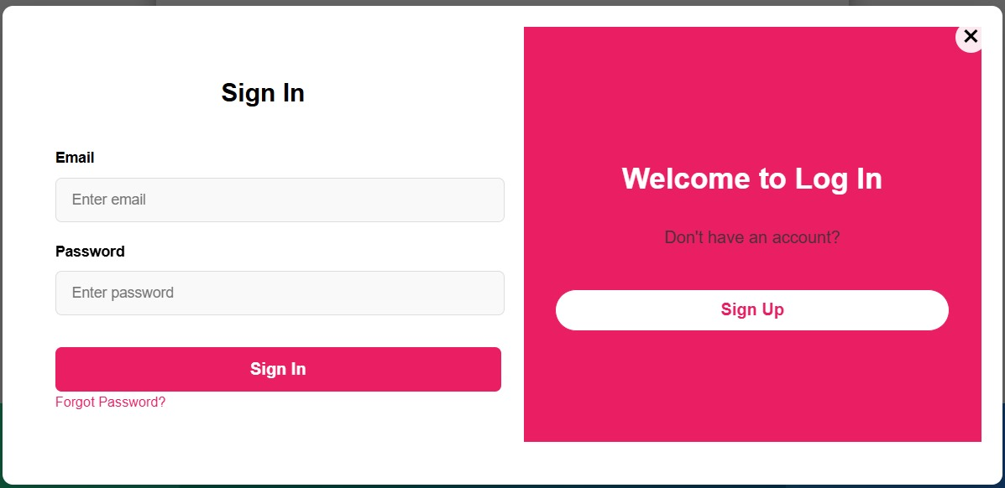

Figure 1 : Login Page

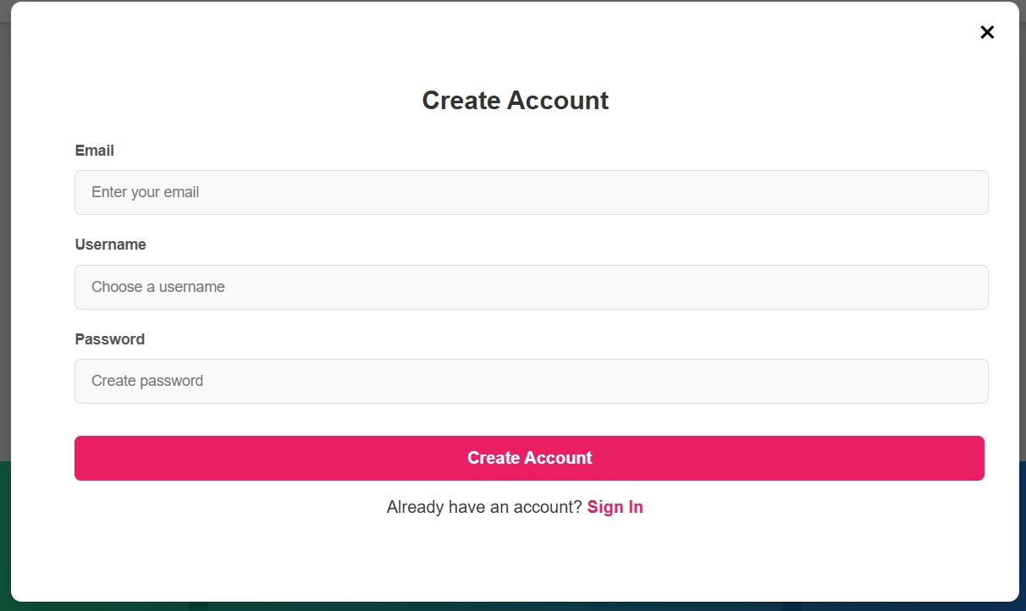

Figure 2 : Create Account

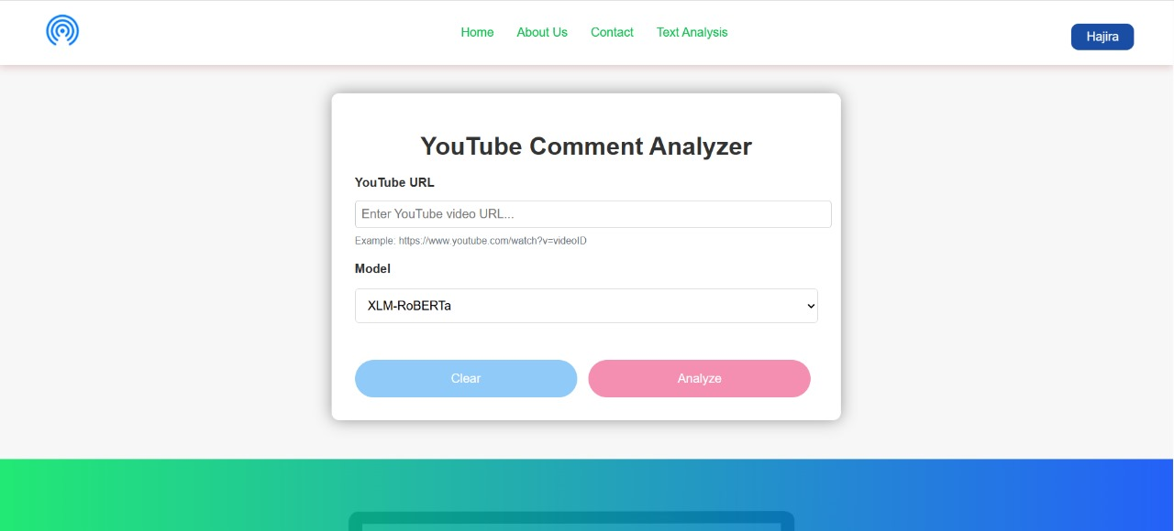

Figure 3 : View Results

* 1. Security Measures

Strong Passwords: Encourage users to set strong, unique passwords.

* 1. FAQs and Support Information

Frequently Asked Questions:

Q: How do I reset my password?

A: Use the "Forgot Password" link on the login page.

Q: How query the system?

A: Paste URL or a single comments and also select a model below dropdown list and then click on submit button for results

Contact: ramzan4777398@gmail.com

8 SYSTEM DESIGN AND CODING SCREENS

* 1. User Interface Design

The front end of this System is user-friendly. It allows users to easily navigate through the pages. The user put a Video URL or a Single Comment to get results. The main components of this system are the Login page, Dashboard, View results, and Contact page. The design of this system is very simple, which makes it easy to new users to use this system. The system is s to all users from anywhere in the world. The tools used to design this system are (HTML, CSS, Java Script, and React) for front-end, and for backend Python, Django, or flask, etc. The design is made flexible using CSS media queries. For user feedback, the contact form will utilized. Wireframes are created to visualize the layout before development. Here are some Wireframes.

Login Wireframe:

* Simple username and password for login
* Forget password link for password recovery

Dashboard Wireframe:

* Navigation menu to navigate through different pages
* A card to take input and to display results

View Result Wireframe:

* Classification results using a pie chart
  1. Login Screen



* The user inputs their username and password in the input fields, and the system verifies the user identity using existing user data stored in a database
* Handle login errors by showing messages to the user
* Maintain cookies and sessions for the users
  1. Registration Screen



* The user just put their username, email, and password to sign up
* Perform Email validation
* For password strength, restrict users to use a combination of passwords, like alphanumeric and special characters
* Email verification to ensure the user does not already exist
* Display a message in case of any error

8.4 Dashboard Design



* The dashboard has Home, About Us, Contact page, and a button to log out
* Two input fields to provide a Comment or a URL
* Two buttons, one to clear input and the other to perform prediction
* Footer contains Contact, About Us, Privacy pages, and social media handles

8.5 Analysis You Tube Comments

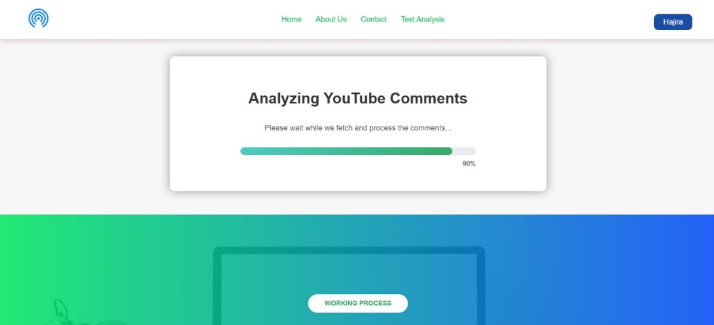

* This Screen contain the Analyzing the You Tube Comments.
* The Comments fetch through API’s and then process.

8.6 Analysis Result

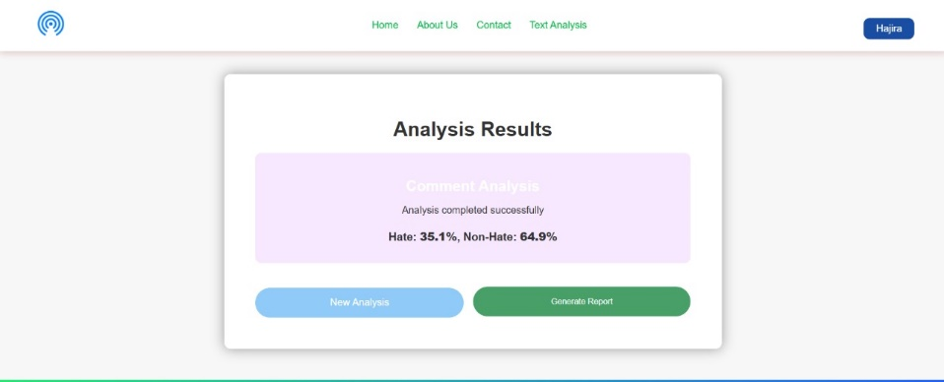

* This screen shows the result of the fetched comments in two categories.
* The result shows in Hate and Non-Hate with its percentage

8.7  View Report

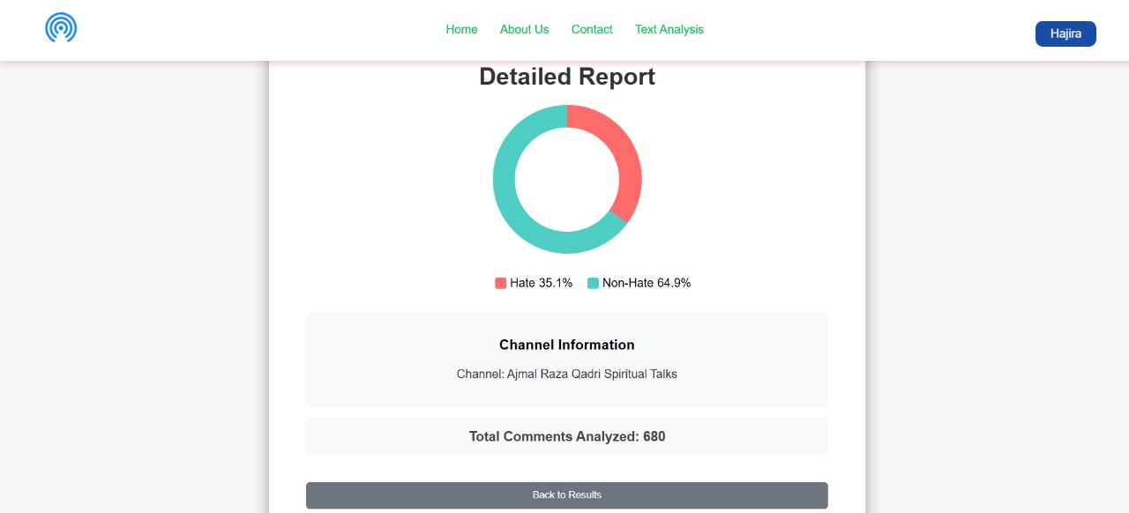

* In this screen user views the result in a Pie Chart in Hate and non-Hate.
* The user also views the YouTube channel name where that type of comment is added.
* Users also view how many comments are analyzed.

8.8 Working Process

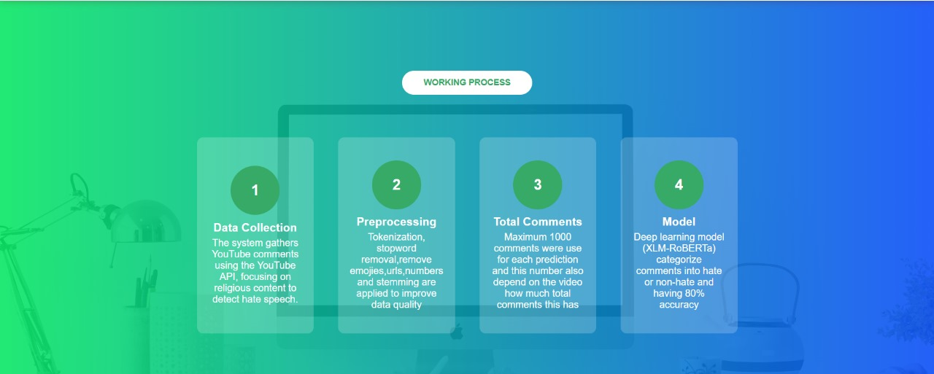

* In this working screen, the four main steps show our system.
* The first step is Data Collection, how our system collects YouTube comments through API’s.
* The second step is preprocessing, in which we remove extra words, URLs, emoji’s, etc.
* The third step is how many comments are used to predict the result.
* In the fourth and last step, we define our model, which we used for prediction.
  1. Text Analysis for Hate Speech Detection

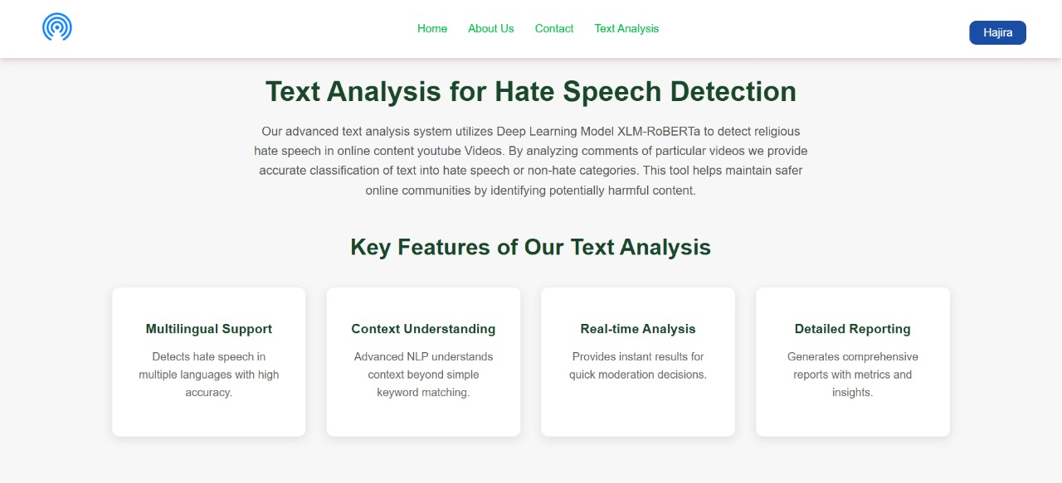

* Our system detect hate speech in multiple languages with high accuracy.
* It provides real-time analysis for quick moderation decision.
  1. Social Media Monitoring

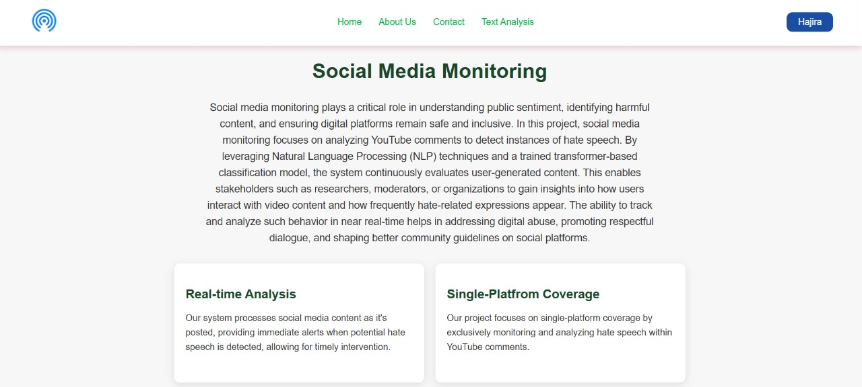

* Our system processes social media content and provides immediate alerts.

* 1. Custom Solution

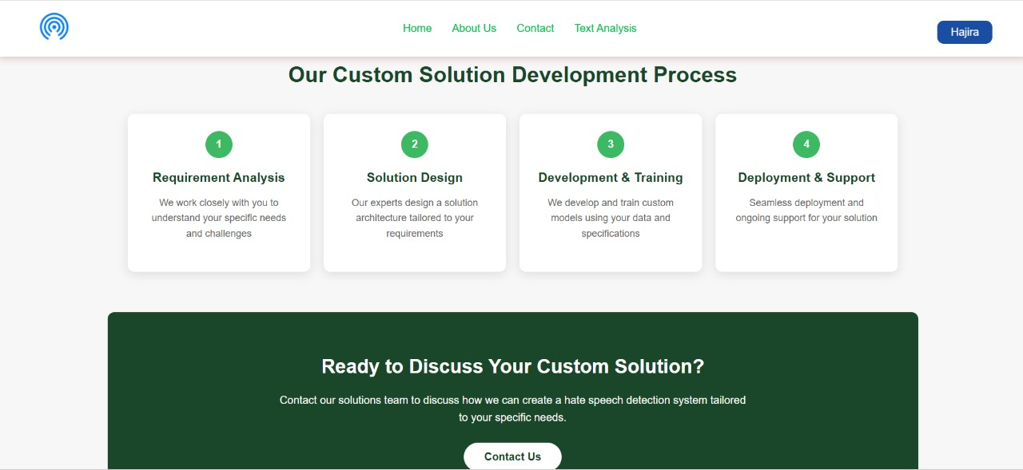

1. Our experts design a solution architecture tailored to your requirements.
2. We develop and train custom models using your data and specifications.
   1. Our Services

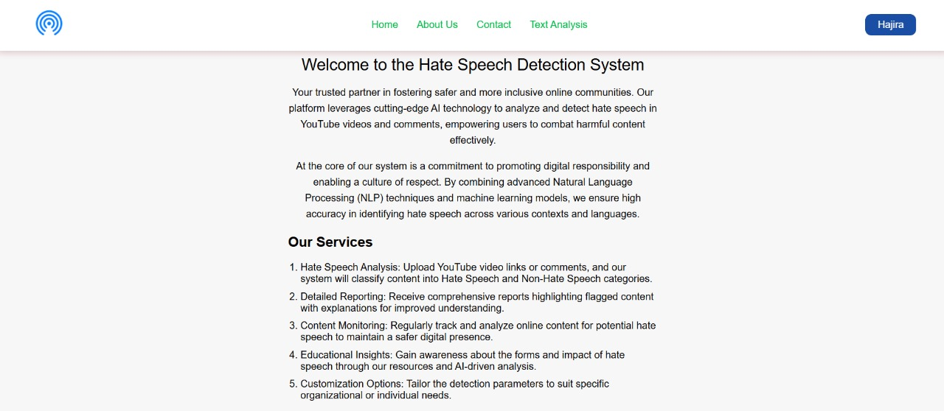

* + - * Our system will accurately classify comments into Hate or Non-Hate
      * Regularly track and analyze online content to maintain a safer digital presence.
  1. Log Out

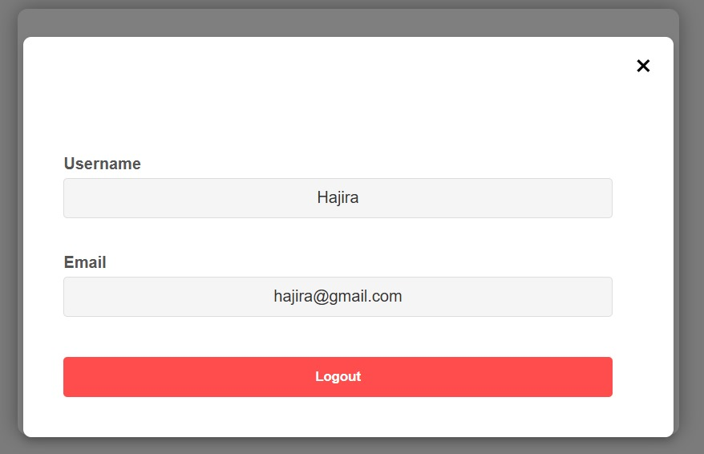

* 1. Footer

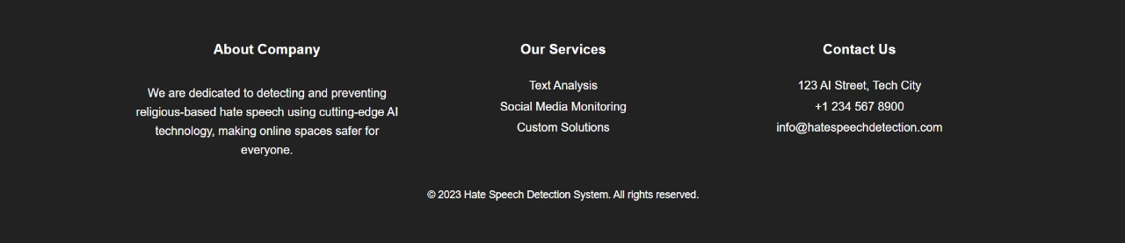

9  CONCLUSION

9.1 **Post-Implementation Summary**  
After implementation, the Religious Hate Speech Detection System successfully analyzes YouTube comments in real time, identifying and flagging harmful content with high accuracy. The system supports multiple users simultaneously and processes large volumes of data quickly, thanks to its scalable, cloud-based architecture. With user-friendly features like video URL input, comment extraction, and automated classification, it provides an efficient tool for content moderation and research, contributing to a safer and more respectful online environment.